GOODS VEHICLE OPERATOR’S LICENCE

THIS LICENCE MUST NOT BE ALTERED OR DEFACED IN ANY WAY

Issued to: Issued by:

BENN HALL  MOULDING SOLUTIONS LTD  WHARF ROAD  KILNHURST  MEXBOROUGH  S64 5SY |  | Office of the Traffic Commissioner  North East of England  Hillcrest House  386 Harehills Lane  Leeds  LS9 6NF  0300 123 9000

Goods Vehicle Restricted Licence number: OB1053933

NOT TRANSFERABLE

This licence is in force from: 20/01/2006

This licence will continue for as long as you continue to meet its terms. However, it will come to an end if you do not pay the necessary continuation fee by the date required. The licence may also face regulatory action including revocation if you operate outside its terms. You have paid for an initial period of five years, which starts with the date the licence was issued. The continuation fee must be paid before the end of the month before that five year period comes to an end and every five years after that. Please see note 1 for further details.

This document is an operator’s licence issued under the Goods Vehicles (Licensing of Operators) Act 1995 (the Act).The undertakings recorded in this licence have been given by the licence holder and are considered to be material to the grant of the licence. In the case of a licence first issued before 1 January 1996, the recorded undertakings include statements of intent made by the operator.

The maximum number of motor vehicles and trailers authorised in accordance with section 6 of the Act is:

Motor vehicles | 10
Trailers (inc semi-trailers) | 10

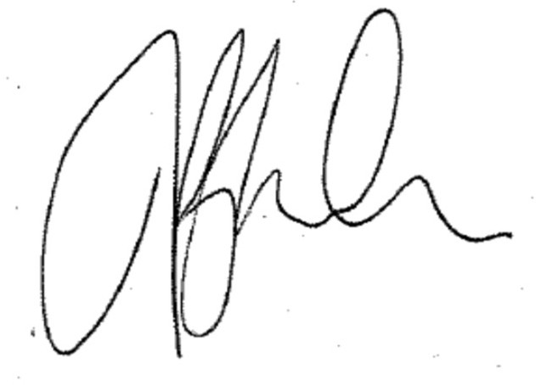

Traffic Commissioner

Operating centre(s)

Operating Centre: | Address:  WHARF ROAD  KILNHURST  MEXBOROUGH  S64 5SY | Vehicles | 10
 |  | Trailers | 10
Conditions or Undertakings

Transport Manager(s)

N/A

Specific conditions attached to licence

Specific undertakings attached to licence

GENERAL CONDITIONS ATTACHED UNDER SECTION 22 OF THE GOODS VEHICLES (LICENSING OF OPERATORS) ACT 1995 – RESTRICTED LICENCES

The licence holder shall, within 28 days of their occurrence, inform the Traffic Commissioner of any:

CHANGES in the maintenance and safety inspection arrangements;

CHANGES in the ownership of the business including partnership arrangements. Company changes in shareholding need not be notified unless they cause a change in the control of the Company;

NOTIFIABLE CONVICTIONS as defined in paragraph 4 of Schedule 2 to the Act

GENERAL UNDERTAKINGS – RESTRICTED LICENCES

The licence holder undertakes to make proper arrangements so that:

The rules on drivers’ hours and tachographs are observed and proper records kept;

Motor vehicles and trailers are not overloaded;

Vehicles will operate within speed limits;

Motor vehicles and trailers, including hired vehicles and trailers, are kept fit and serviceable;

Drivers report promptly any defects or symptoms of defects that could prevent the safe operation of vehicles and/or trailers, and that any defects are promptly recorded in writing;

Records are kept (for 15 months) of all driver defect reports, all safety inspections, routine maintenance and repairs to vehicles and trailers and these are made available on request; and

In respect of each operating centre specified, that the number of authorised motor vehicles and the number of authorised trailers kept there will not exceed the maximum numbers recorded against the operating centre in this licence.

My promises as a Restricted Licence holder

I have promised:

to keep vehicles taxed, insured and in MOT

to check that drivers have the right licence to drive HGVs

to keep vehicles and trailers roadworthy and not overload them

to obey drivers’ hours and tachograph rules (so I will need to know what they are)

that drivers will do a daily walk-round check of the vehicle (recorded in writing) before starting to drive

to keep vehicle maintenance and driver check records for 15 months

not to operate more than the maximum number of vehicles on the licence

to operate only from the operating centre(s) on the licence

to tell the Traffic Commissioner within 28 days:
about any convictions of myself or my staff
a change in maintenance arrangements
a planned change in entity (eg from sole trader to partnership or limited company)
a change in financial status (eg bankruptcy or entering administration)

If I fail to keep these promises, I could lose my licence.

Notes:

1. The continuation fee is payable before the end of the month which precedes the date of expiry of a period of 5 years, beginning with the date of either the issuing of the licence or the most recent 5 year anniversary of that date, whichever is the later. There is no legal obligation for the traffic commissioner to send a reminder that the continuation fee is due although a licence checklist will be sent to the correspondence address of the licence holder kept on file. If you have received no contact two weeks before the continuation date, please urgently contact the Central Licensing Office.

2. The “holder” of a licence is the person to whom the licence was issued. An operating centre is defined as the base or centre at which the licence holder’s vehicles (and trailers) are normally kept. Every five years, for a period of two months the traffic commissioner has the power under section 30 of the Goods Vehicles (Licensing of Operators) Act 1995 to review the suitability of an operating centre should there be any concerns. If a review is to be conducted an operator will be contacted in writing.

3. This licence authorises the use of a maximum number of vehicles and trailers by the licence holder. Vehicles currently in the holder’s possession, and for which vehicle discs have been issued, are recorded as “specified” vehicles on the licence. The difference between the number of vehicles in possession and the total authorisation is known as the “margin”.

4. Within the margin, the licence holder may operate vehicles additional to those currently specified on the licence (but without exceeding the total authorisation) for a maximum of one month beginning with the day on which the vehicle was first in the licence holder’s lawful possession. If the period of use of any vehicle is one month or less there is no requirement to notify the central licensing office. To use a vehicle for more than one month, and remain within the law, the licence holder must inform the central licensing office before that month is up. The vehicle then becomes specified on the licence and the margin is reduced accordingly.

5. If the vehicles specified on the licence are equal to the total authorisation, the holder cannot operate any additional vehicles, temporarily or otherwise, without having first applied for, and been granted, authority to do so.

6. The licence holder cannot change or add an operating centre without having first applied for, and been granted, authority to do so. Failure to obtain authority to use a place as an operating centre may result in a fine on summary conviction and disciplinary action being taken against the licence.

7. In addition to the general conditions detailed elsewhere in this document, legislation requires licence holders to inform the traffic commissioner of any change of correspondence address, within 28 days. Failure to inform the traffic commissioner of a change of correspondence address may result in the revocation of the licence.

8. A licence holder who does not fulfil an undertaking or condition recorded on his licence may be committing an offence and will be liable to disciplinary action by the traffic commissioner. A licence may be revoked, suspended or curtailed.

